

Software Engineering (CS328)

**“Deliverable {4} – {Iteration 1 / Sprint 3}”**

**Student Names: Registration Number:**

Ahmed Wadood 19I-1858

Arsalan Ahmed 19I-1875

Talha Ilyas 19I-1887

**Team Name:** Collaborators

**Degree Program:** BS (DS)

**Section:** N

**Course Name:** Software Engineering

**Date of Submission:** May 25, 2021

**Submitted to:** Dr. Noreen Jamil

**1.Architecture Diagram**

**(The template form of architecture will be part of report, this is beta version of architecture)**

**a.** I chose Layered architecture system as it handles the number of domains of our project more efficiently because it allows you to work in both open and closed layered architecture. Each layer use the services of the layer above it. It also reduce the impact of change in a layer. It also supports the increasing level of abstraction of the project during design. We can also define standard layer interfaces for each domain.

**2. Sprint Backlog**

**Part a:**

**Name of Module: Service Charges, location tracking and feedback process**

**Information for This Module:**

**Part 1: For Customers**

1. We will be using advanced search filters. The customers can choose from any service available. Once they choose a particular service, a pop-up will come which contains packages. Users can select the package according to their budget.
2. In order to connect the customer with a trusted professional, we will implement location based mechanism which will make sure the nearest professional available appears at the top of search results.

**Part 2: For Admin**

* This part of module overview the service charges of Professionals on respective hours and their experience.

**Part 3: For Professionals**

1. In the registration process, the charges of services will be already defined. The professionals will have to set their hourly charges themselves. These charges will appear in their profiles.
2. The review/Feedback mechanism will be accessible to professionals but the identity of the customer who entered the feedback will not be accessible to the professional.

**Part b: Sprint: 3**

|  |
| --- |
| **Story ID**: 01 **Story Title**: Services charges |
| **­­­­User Story: Importance:**  **Type**:  **Estimate**:  Workflow  4  1   |  | | --- | | As a professional, I want the charges of my services properly defined so I will be paid accordingly. |   **Acceptance Criteria:**   |  | | --- | | I know I’m done with service charges process when A pop up appears verifying that the professional was paid. | |

|  |  |  |
| --- | --- | --- |
| **Story ID**: 02 **Story Title**: Location Tracking  **­­­­User Story: Importance:**  Workflow  3  **Type**:  **Estimate**:  2   |  | | --- | | As a professional, I want to be able to use track the address of the customer so I can reach the customer comfortably. |   **Acceptance Criteria:**   |  | | --- | | I know that location system is working when The exact location of the customer appears in my mobile App. | |

|  |  |  |
| --- | --- | --- |
| **Story ID**: 03 **Story Title**: Feedback System  **­­­­User Story: Importance:**  Workflow  3  **Type**:  **Estimate**:  2   |  | | --- | | As a professional, I want my reviews public to me so I can improve myself for the next task. |   **Acceptance Criteria:**   |  | | --- | | I know feedback mechanism is working when My reviews and feedbacks appear in my account. | |

**Part c:**

**Tasks for User Stories:**

1. Define proper hourly charges for a specific service.

2. Option for GPS location tracking of customer or professional.

3. Option for the customer to give feedback.

4. Graphics used for the review system.

5. Calculation of rating of professional on basis of reviews.

6. GUI for the app.

7. Search bar in the webpage.

8. Testing of all above mentioned tasks.

**3.Sprint 3 Output**

**a.**

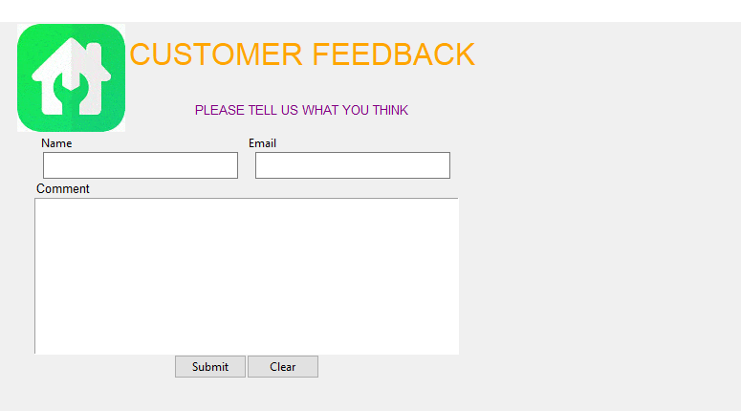

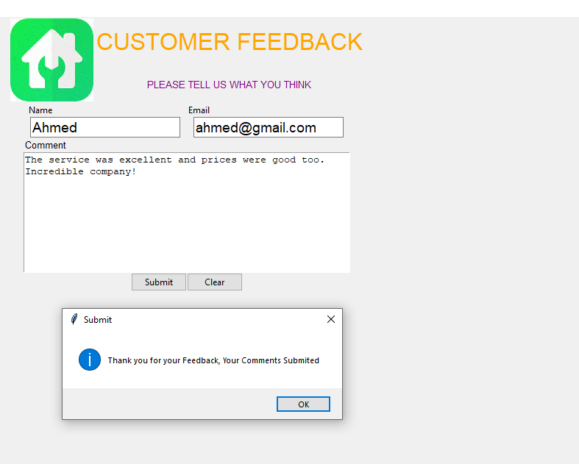





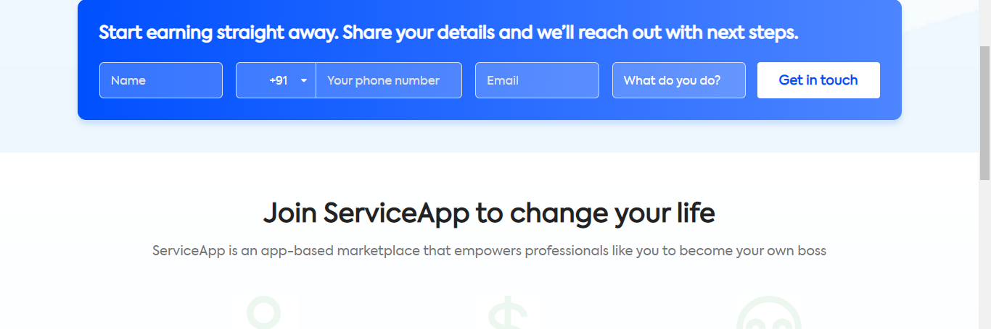

**b.**

**Trello Initial State:**

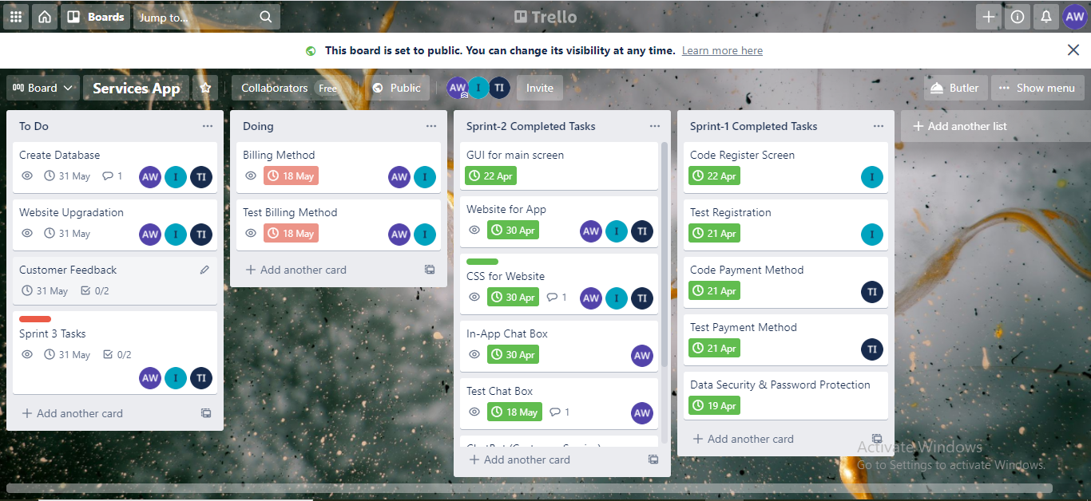

**Trello Middle State:**

**Trello Final State:**

**Product Burndown Chart:**

